

**National Park Service**

**U.S. Department of the Interior**

**Saguaro Douglas Fir (PSME) Plots QAQC and Analysis**

April 2024

Eva Deegan, SIP Intern

Windy Bunn, Fire Ecologist

Gabe DeJong, Fire Ecologist

National Park Service

Intermountain Region

Contents

1 Summary 3

2 Figures 3

3 Appendices 4

4 Introduction and Objectives 4

5 QAQC 6

5.1.1 Methodology 6

5.1.2 DBH transfer issue 6

5.2 Cover Protocol Data Utility 8

5.2.1 Canopy Cover 8

5.2.2 Most Common Herbaceous Species 8

5.2.3 Additional Species 10

5.2.4 Invasive Species 10

5.3 Overall Recommendations for Cover Data 10

6 Analysis 10

6.1 Summary of PSME Objectives (FMH 2001 – Appendix C.) 10

6.2 Objective 1. Reduce total fuel load by 30-50% one year post burn while maintaining total 1000hr fuels at 5-7 tons/acre 11

6.2.1 Results 11

6.2.2 Discussion 11

6.3 Objective 2. Reduce pole sized tree density by 30-50% two years post burn 12

6.3.1 Results 12

6.3.2 Discussion 12

6.4 Objective 3. Limit overstory tree mortality to ≤ 10% five years post burn 13

6.4.1 Results 13

6.4.2 Discussion 14

6.5 Objective 4. Increase herbaceous cover by 5-10% and increase diversity five years post burn 14

6.5.1 Discussion 14

7 Additional Analyses 14

7.1 Summary 14

7.2 Post Burn Severity 14

7.2.1 Results 14

7.2.2 Discussion 15

16

7.3 Seedlings 19

7.3.1 Results 19

7.3.2 Discussion 19

7.4 Species Composition and Basal area 20

7.4.1 Results 20

7.4.2 Discussion 22

8 Conclusion 23

9 Management Recommendations 24

10 Literature Cited 25

# Summary

This report was created by Eva Deegan, a Scientists in Parks intern from June 2023 – June 2024, as a summary of her quality control and analysis performed on the Douglas Fir fire effects data from Saguaro National Park. Throughout her internship, Eva developed code in R to systematically perform quality control and analysis on data from Feat-Firemon Integrated (FFI) to inform fire management decision making. This report is intended to provide results and management recommendations from Eva’s work for fire operations and future fire ecologists. The report includes analysis of the full history of ten Douglas Fir plots on Mica Mountain in Saguaro National park as well as information about the quality and state of the data.

# Figures

*Table 1. Douglas fir (Pseudotsuga menziesii; PSME) FMH monitoring plots and measurement years.*

*Table 2. Live Tree Basal Area for PSME plots that burned in stand replacing fires (PSME-03, PSME-07, PSME-08, PSME-09) with data for each species. Douglas fir rows are highlighted.*

*Figure 1. Historical data visualization of PSME plots, what year they burned, and which protocols were collected.*

*Figure 2. A visualization showing missing DBHs and DBH transfer throughout the plot history.*

*Figure 3. Canopy cover from 2004 - 2023. No significant difference was found between years (p=0.14)*

*Figure 4. Canopy cover compared to total basal area per acre*

*Figure 5. Most common herbaceous species (common names) recorded from 2008 to 2023.*

*Figure 6. Percentage of grasses recorded to forbs recorded in most common herbaceous species data in Douglas fir plots.*

*Figure 7. Canopy cover data compared to count data of grasses and forbs in Douglas Fir plots.*

*Figure 8. Count of additional species recorded per plot from 2008 - 2023 for Douglas Fir plots*

*Figure 9. Douglas Fir plots fuel loading over time.*

*Figure 10a. Fuel loading (tons/acre) by size class adjusted to y scale.*

*Figure 10b. Fuel loading (tons/acre in Douglas Fir plots by size class at a fixed y scale.*

*Figure 11. Douglas Fir plot with dead and down trees.*

*Figure 12. Pole tree density from 2001 to 2023.*

*Figure 13. Overstory tree mortality from 2001 – 2023.*

*Figure 14. Live tree density pre-fire, immediately post-fire, and 20 years later, separated by size class and plot.*

*Figure 15. Total Pre-Fire Fuel Loading, Mean Pole Tree Height, and Mean Pole Tree Density per plot compared to Post-Burn Severity Metrics*

*Figure 16. Map of Douglas Fir (PSME) plots on Mica Mountain. The plots circled in red had the highest burn severity with stand replacing fires and the plots circled in green had lower severity burns*

*Figure 17. Map of fire progression with PSME plot locations. Refer to Figure 15. for labels of each individual plot. All plots were burned on June 20th, 2003, during the fire that burned from June 17th to June 28th.*

*Figure 18. Douglas Fir plots seedling density over time by species and size class.*

*Figure 19. Climate Analyzer Normalized Reconnaissance Drought Index Data from high elevation RMD RAWS station 2000 - 2023. “NA” = insufficient data to generate reliable estimates. Data Source: GRIDMET via climateanalyzer.org*

*Figure 20. Live Tree Species Composition Over Time*

*Figure 21. Live Tree Basal Area for PSME plots that burned in non-stand replacing fires (PSME-01, PSME-02, PSME-04, PSME-05, PSME-06, PSME-10)*

*Figure 22. Live Tree Basal Area for PSME plots that burned in stand replacing fires (PSME-03, PSME-07, PSME-08, PSME-09)*

*Figure 22. Perimeter of Helen’s 2 fire (2003) and fire severity with Saguaro National Park Rincon Mountain District boundary.*

*Figure 24. PSME plot locations with fire severity.*

# Appendices

Appendix A: [Helen2_Assessment.doc (sharepoint.com)](https://doimspp-my.sharepoint.com/:w:/r/personal/wbunn_nps_gov/_layouts/15/Doc.aspx?sourcedoc=%7BA79D31D6-719C-4EEB-BAB2-F583C925CA44%7D&file=Helen2_Assessment.doc&action=default&mobileredirect=true)

Appendix B: [Saguaro FFI QAQC Process.docx (sharepoint.com)](https://doimspp-my.sharepoint.com/:w:/r/personal/edeegan_nps_gov/_layouts/15/Doc.aspx?sourcedoc=%7B025FFC11-B36E-4C8E-A52A-77984AB46C62%7D&file=Saguaro%20FFI%20QAQC%20Process.docx&action=default&mobileredirect=true)

Appendix C: [PSME10.doc (sharepoint.com)](https://doimspp-my.sharepoint.com/:w:/r/personal/wbunn_nps_gov/_layouts/15/Doc.aspx?sourcedoc=%7B32678879-0412-4451-B58D-7056C4A0C1C1%7D&file=PSME10.doc&action=default&mobileredirect=true)

Appendix D: Galvin J and Studd S. 2021. Vegetation inventory, mapping and characterization re-port, Saguaro National Park: Volume I, main report. Natural Resource Report. NPS/SODN/NRR—2021/2233. National Park Service. Fort Collins, Colorado. https://doi.org/10.36967/nrr-2284709

# Introduction and Objectives

**Overview:** This type was developed in the early 1990’s and is dominated by Douglas-fir (Pseudotsuga menziesii). It is found on the North Slope of the Rincon Mountains.

**Physical Description:** Aspects mostly northerly; Slopes range from 25 to 75% with an average of 40%; elevation ranges from 7000 to 8600 feet; mid and upper slopes; the area is characterized by steep slopes, punctuated by wet drainages and rocky ridgelines.

**Biological Description:** Canopy varies from 50-70% closure. The dominant overstory tree is Doug Fir (Psudotsuga menziesii). Co-dominant species include Ponderosa (Pinus ponderosa), Southwerstern white pine (Pinus strobiformis), White Fir (Abies concolor) and Gambel Oak (Quercus gambelii). Understory is very dense reaching 70% closure with the above-mentioned tree seedlings and shrubs such as Snowberry (Symphoricarpos oreophilus) and Mountain spray (Holodiscus dumosus). Herbaceous understory consists of seasonal annuals and some grasses. This entire area is characterized by high fuel loading of all dead and downsize classes. See Appendix C. (PSME FMH) for more information on the Douglas Fir Monitoring Type plots.

|  | | Monitoring Status and Measurement Year | | | | | | |
| --- | --- | --- | --- | --- | --- | --- | --- | --- |
| Fire – Year Burned | Plot ID | 01Pre* | 01Post | 01Year01 | 01Year02 | 01Year05 | 01Year10 | 01Year20 |
| Helen’s 2 WF – 2003 | PSME-01 | 2001 | 2003 | 2004 | – | 2008 | 2013 | 2023 |
| Helen’s 2 WF – 2003 | PSME-02 | 2001 | 2003 | 2004 | – | 2008 | 2013 | 2023 |
| Helen’s 2 WF – 2003 | PSME-03 | 2001 | 2003 | 2004 | – | 2008 | 2013 | 2023 |
| Helen’s 2 WF – 2003 | PSME-04 | 2001 | 2003 | 2004 | – | 2008 | 2013 | 2023 |
| Helen’s 2 WF – 2003 | PSME-05 | 2001 | 2003 | 2004 | – | 2008 | 2013 | 2023 |
| Helen’s 2 WF – 2003 | PSME-06 | 2001 | 2003 | 2004 | – | 2008 | 2013 | 2023 |
| Helen’s 2 WF – 2003 | PSME-07 | 2001 | 2003 | 2004 | – | 2008 | 2013 | 2023 |
| Helen’s 2 WF – 2003 | PSME-08 | 2001 | 2003 | 2004 | – | 2008 | 2013 | 2023 |
| Helen’s 2 WF – 2003 | PSME-09 | 2001 | 2003 | 2004 | – | 2008 | 2013 | 2023 |
| Helen’s 2 WF – 2003 | PSME-10 | 2001 | 2003 | 2004 | – | 2008 | 2013 | 2023 |

Table 1. Douglas fir (Pseudotsuga menziesii; PSME) FMH monitoring plots and measurement years. Monitoring status is the time of measurement in relation to fire activity: 01Pre – before fire, 01Post – immediately after the first fire, 01Year01 – 1 year after the first fire, 01Year01 – 1 year after the first fire, etc. ”–“ indicates missed measurements. *01Pre is the most recent pre-fire measurement. Previous measurements occurred in all plots in 1997 and in all plots expect PSME-10 between 1990 and 1992.The plots were not burned before measurements were repeated in 2001.

The following objectives were developed for the burn in 2001:

1. Reduce total fuel load by 30-50% one year post burn while maintaining total 1000hr fuels at 5-7 tons/acre
2. Reduce pole sized tree density by 30-50% two years post burn
3. Limit overstory tree mortality to ≤ 10% five years post burn
4. Increase herbaceous cover by 5-10% and increase diversity five years post burn

The prescribed burn planned for 2001 was not accomplished but the plots did burn in 2003 in the Helen’s 2 Wildfire. More information about the Helen’s 2 Wildfire can be found in the post burn assessment in Appendix A.

# QAQC

### Methodology

Quality assurance and control was performed using code in R studio. The code was developed to automate the QAQC process, increase efficiency, and improve documentation of changes made in the QAQC process. Information about the new QAQC process is described in depth in the Saguaro FFI QAQC Process document in Appendix B. The code included visualizations of the sample events which can be seen in Figure 1. This visualization helped us see what data was collected what year in the PSME plots.

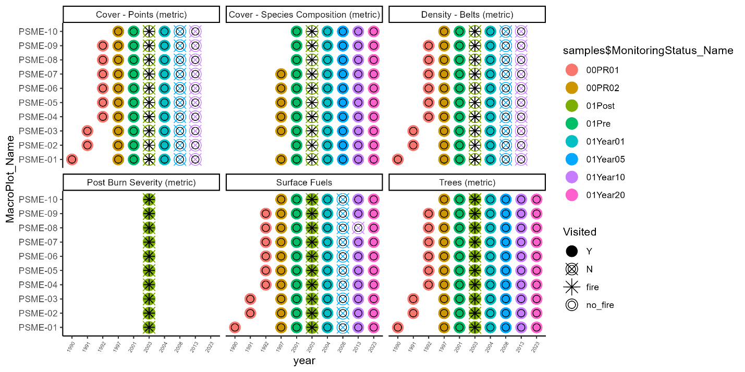

Figure . Historical data visualization of PSME plots, what year they burned, and which protocols were collected.

### DBH transfer issue

While performing quality control on the Douglas Fir data we discovered that DBH was not recorded for two years in the dataset; 2003 and 2008 (except plots PSME-05 and PSME-10). 2003 was the post-fire read, focused on collecting status and post burn severity data which is likely why no DBH data was collected. However, it is unknown why DBH data was not collected for most plots in 2008. Crown class data is also missing in 2008. At some point, DBH data was transferred from 2004 to 2003 for each individual tree. Some DBH data was transferred from 2004 to 2008 (PSME-04 and PSME-09), but for many plots DBH was left blank. Figure 2 summarizes which plots have missing DBH data, DBH data transferred from previous years and subsequent years.

We decided to fill out the rest of the DBH data in 2008 with DBH values for each tree from 2004. We did this while knowing the DBH wouldn’t be completely accurate because to evaluate change over time in other metrics such as mortality, density, or species composition for trees of different size class, we need DBH data to organize tree tags by size class. After completing the 2008 DBH data and adding comments noting that the DBH was transferred from 2004, we were able to complete many key analyses that included size class and mortality data from 2008.

Figure 2. A visualization showing missing DBHs and DBH transfer throughout the plot history.

## Cover Protocol Data Utility

### Canopy Cover

Starting in 2004, Saguaro fire effects began collecting data with a new protocol, labeled Cover – Species Composition (metric) in FFI. The data collected included an estimation of canopy cover in each quarter of the forest plot, using five categories: 0 (0%), 1 (1-20%), 2 (21 - 50%), 3 (51 - 80%), or 4 (81-100%). These classes were recorded as range midpoints in FFI, with the following values: 0%, 10%, 37.5%, 62.5%, or 100% canopy cover.

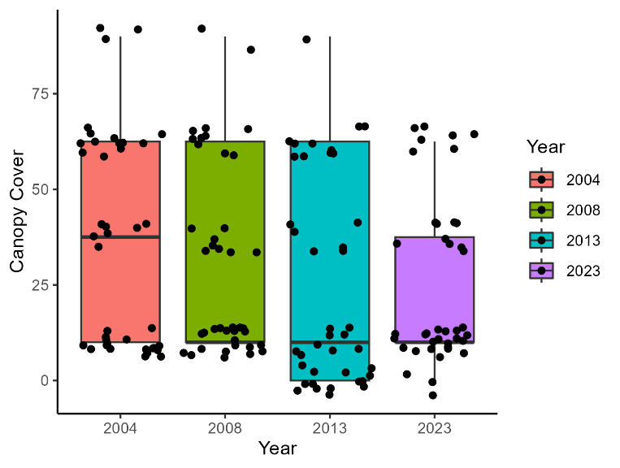

Figure 3. Canopy cover from 2004 - 2023. No significant difference was found between years (p=0.14)

In the Spring of 2024, we evaluated these data and found little potential utility. We found no significant difference in canopy cover between years (Figure 3). Canopy covers were compared to the most common herbaceous species identified in plots and proportions of grasses and forbs recorded in plots. No significant trends over time or correlations between canopy cover and species composition were found (Figure 7).

Figure 4. Canopy cover compared to total basal area per acre

Canopy cover was plotted against total basal area per acre for each corresponding plot and year and we ran a linear model to determine the relationship between the variables. There was a significant relationship between these two variables (r-squared adjusted= 0.6136, p= 3.072e-07). While it was good to see that the expected relationship between canopy cover and basal area was held true with these protocols (and was statistically significant), there seems to be little utility in collecting canopy cover classes when trees are being measured for DBH. Additionally, live crown base height could be a valuable measurement for similar management questions if we continue to collect it for each tree, as was done in 2023.

### Most Common Herbaceous Species

In 2008 under the Cover – Species Composition protocol, Saguaro fire effects staff began recording the three most common species found in each forest plot. We have several concerns about the quality and utility of these observations. First, fire effects crews are rarely trained in botany and often lack proper plant identification skills, therefore the accuracy of this data is in question. In many instances, the plants were not identified to species, but recorded as “unknown forb” or “unknown grass”. Second, many plots are simply missing observations, presumably due to a lack of confidence in plant identification or forgetting to complete the protocol. Third, the vegetation crew at SODN have already collected high-quality vegetation data from Mica Mountain and have published their results (Appendix D). Their findings are a more reliable source for describing the common herbaceous species in these natural communities.

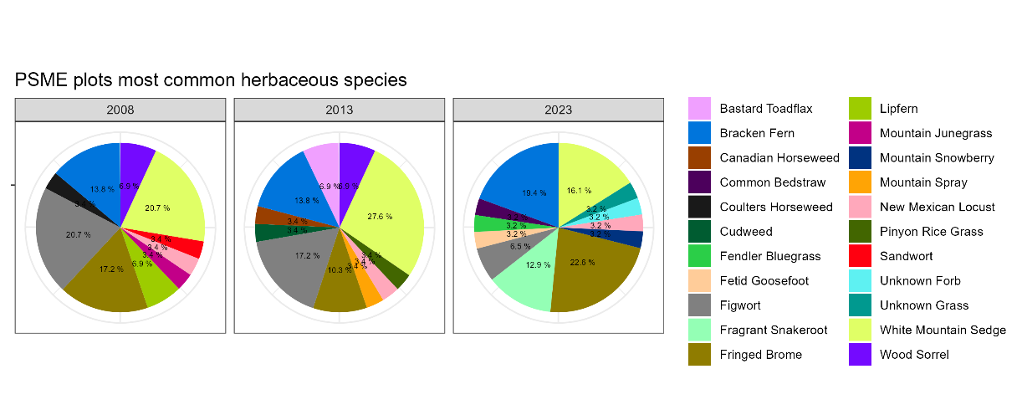

Figure 5. Most common herbaceous species (common names) recorded from 2008 to 2023.

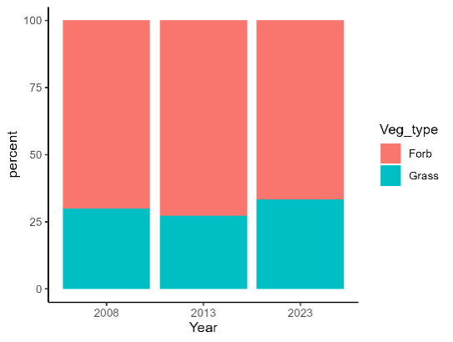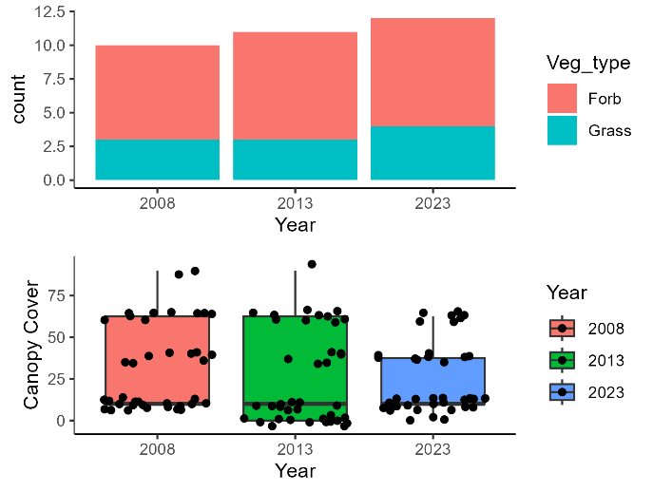

Figure 6. Percentage of grasses recorded to forbs recorded in most common herbaceous species data in Douglas fir plots.

Figure 7. Canopy cover data compared to count data of grasses and forbs in Douglas Fir plots.

We investigated the utility of this protocol by looking at changes in species composition over time (Figure 5), proportions of grasses and forbs over time, (Figure 6), and correlations between species composition and canopy cover (Figure 7). There was no significant difference in the proportion of graminoids vs. forbs between years and no significant correlation with canopy cover. After examining the results, we did not find any trends worth noting. This brings into question the reliability and utility of this metric.

### Additional Species

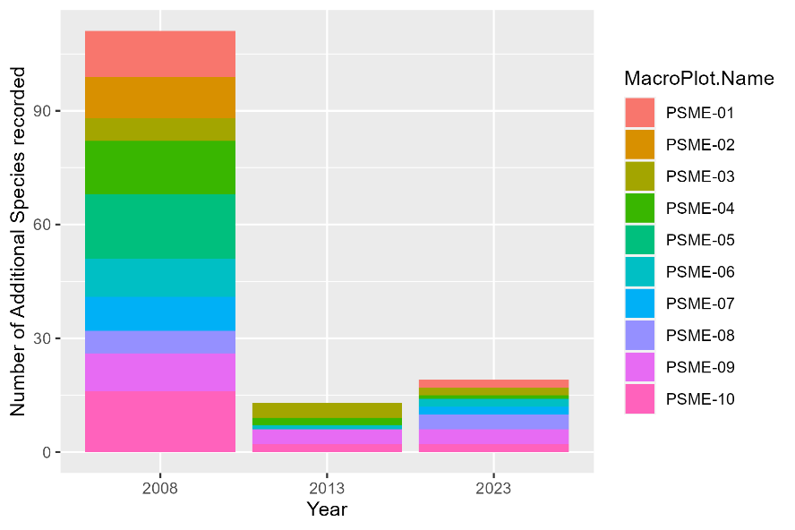

Figure 8. Count of additional species recorded per plot from 2008 - 2023 for Douglas Fir plots

In addition to the three most common herbaceous species, crews had the option to record any additional species of note. No data was collected for additional species in 2004. Figure 8 shows a count of how many species were recorded from 2008 – 2023. Many additional species were recorded in 2008 and few were recorded in subsequent years. We have the same concerns with this data as the most common herbaceous species data, as well as its inconsistency over time.

### Invasive Species

During the four years this protocol has been in use, there have only been two instances when an invasive species was recorded: *Trifolium pinetorum* in PSME-03 (2023), and Bromus rubens in PSME-08 (2013), which was subsequently pulled.

## Overall Recommendations for Cover Data

1. Discontinue current herbaceous species protocol
   1. Instead – collaborate with SODN vegetation monitoring crew and use data collected for Saguaro vegetation inventory.
   2. Brainstorm options for a more useful herbaceous data protocol.
2. Discontinue canopy cover protocol
   1. Instead – continue collecting live crown base height data for individual trees
3. Train fire effects crews to recognize, report, and treat local invasive species of concern appropriately when encountered, and include a note in the comments section of the plot data.

# Analysis

## Summary of PSME Objectives (FMH 2001 – Appendix C.)

1. Reduce total fuel load by 30-50% one year post burn while maintaining total 1000hr fuels at 5-7 tons/acre
   1. Objective met with excess (57.2% decrease) (Figure 9.)
2. Reduce pole sized tree density by 30-50% two years post burn
   1. Objective met (47.2% decrease) (Figure 12.)
3. Limit overstory tree mortality to ≤ 10% five years post burn
   1. Objective not met (45.9 % mortality) (Figure 13.)
4. Increase herbaceous cover by 5-10% and increase diversity five years post burn
   1. Insufficient data to evaluate objective

## Objective 1. Reduce total fuel load by 30-50% one year post burn while maintaining total 1000hr fuels at 5-7 tons/acre

### Results

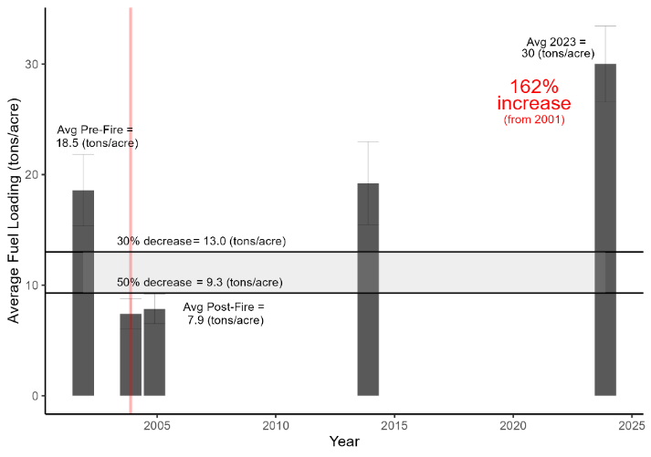

Figure 9. Douglas Fir plots fuel loading over time.

Our objective to decrease fuel loading between 30 – 50% 1-year post fire was exceeded. Average fuel loading post fire decreased by 57.2%, going from 18.5 tons/ac. pre-fire to 7.9 tons/ac. post fire. Data collected in the 20 years post-fire show that fuel loads have steadily increased and were 162% above pre-fire levels by 2023 (Fig. 9).When looking at fuel loads by fuel moisture class, all categories except one-hour fuels experienced increases in fuel loading, to higher than pre-fire levels. (Figure 10a). The 1000hr fuels were the greatest contributor to overall fuel loads (79% of total in 2023, Fig. 10b)

### Discussion

The desired reduction in fuel loading was met and exceeded. A major contributing factor to this result was the fact that the plots burned in a wildfire (with many of the plots experiencing high fire intensity), rather than by a prescribed burn. The resulting high-intensity wildfire consumed more of the available fuel than would have been expected under more controlled conditions. The increased fuel loading of 1000hr fuels is likely be attributable to the accumulation of dead and down trees over the past 20 years since the fire (Figs. 10a, 10b and 11). As of 2023, fuel loads in the plots were at hazardous levels, especially when considering that these levels representing higher fuel loads than were present before the 2003 wildfire. This level of fuel loading, especially of the large 1000hr fuels, could result in another catastrophic wildfire, potentially slowing or even altering the trajectory of succession/recovery in this community. Studies in Chiricahua National Monument after the 2011 horseshoe fire showed a shift in dominance from trees prior to the fire to shrub species after the fire, dependent on fire severity and vegetation type (Poulos et al. 2021). More research is needed to determine the potential of a fire catalyzed vegetation shift in Saguaro National Park’s mixed conifer forest (see sections 7.3.2 and 7.3.3).

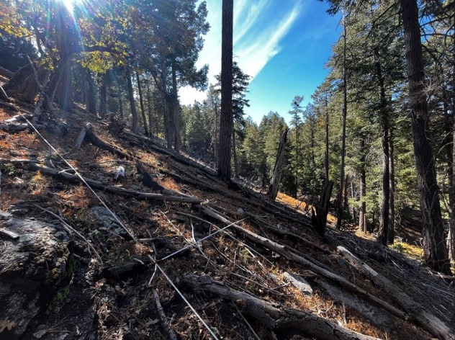

Figure 11. Douglas Fir plot with dead and down trees in 2023.

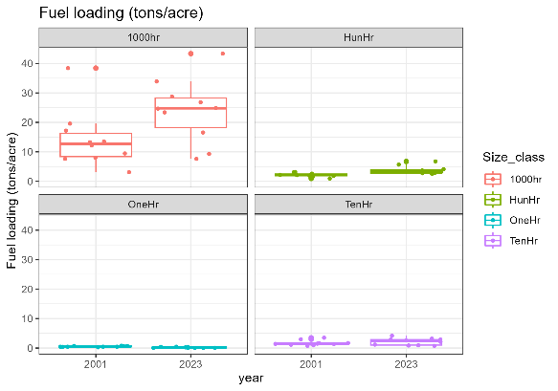

Figure 10b. Fuel loading (tons/ac.) in Douglas Fir plots by size class and at equal y scale.

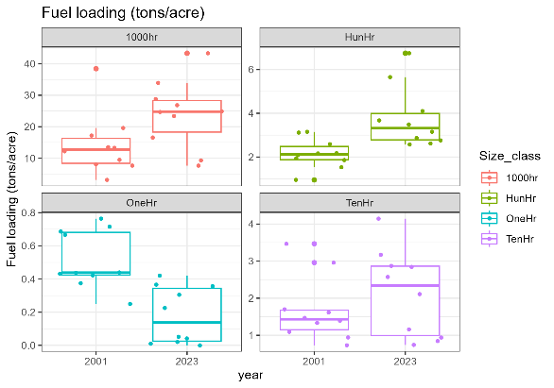

Figure 10a. Fuel loading (tons/acre) by size class, adjusted to y scale.

## Objective 2. Reduce pole sized tree density by 30-50% two years post burn

### Results

The objective to reduce pole sized tree density by 30-50% two years post burn was met, as live pole tree density decreased by 47.2% compared to the pre-fire average. Twenty years after the fire, live pole tree density averaged 7.3 stems/ac., a 59% decrease from pre-fire levels.

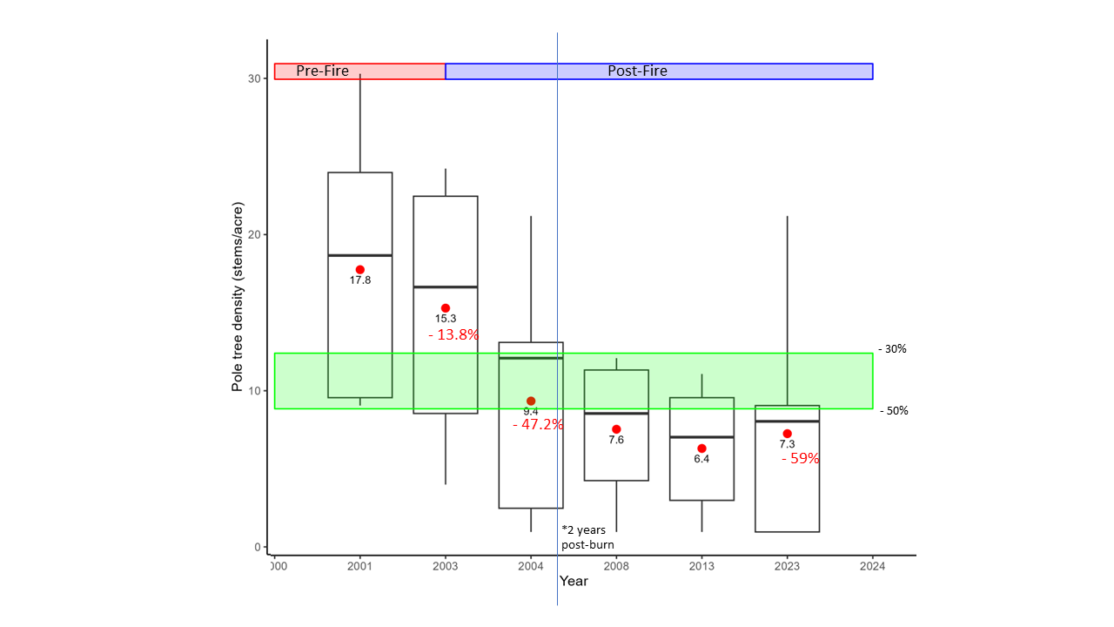

Figure 12. Pole tree density from 2001 to 2023.

### Discussion

While the current pole tree density is close to the desired level based on the original prescribed burn objective, the overall decrease is a potential area of concern for regeneration and the long-term recovery of the community. When considering future fires, both planned and unplanned, as well as other disturbances, will there be enough surviving trees of the desired species composition to recover the mixed conifer community? To preserve the mixed conifer forest on Mica Mountain, management practices should encourage the growth of overstory trees, many of which died in the 2003 wildfire (Fig. 12.)

Though pole tree density had a higher average in the 20-year read than the 10-year read, there is greater plot-to-plot variability. This indicates while certain plots are recovering well, others have very low pole tree density and have struggled to recover from the fire (see Fig. 14 for pole tree density by plot). This requires further investigation, perhaps by comparing seedling density and species composition of different size classes.

Future analyses could consider using the Forest Vegetation Simulator to determine an ideal range of pole tree densities. This could help define desired future conditions. Using modeling to investigate the potential effects of climate change would be helpful to create an adaptable management plan. We recommend that new objectives be developed for pole tree density using desired future conditions and considering the diversity of current plot conditions.

## Objective 3. Limit overstory tree mortality to ≤ 10% five years post burn

### Results

The objective to limit overstory tree mortality to less than 10% five years post burn was not met. The live tree count decreased 42.6% immediately after the fire. By five years post fire, the live overstory tree count was 176, a 61.3% decrease from pre-fire levels (456). Twenty years after the fire, 180 live overstory trees were recorded in all the Douglas Fir plots, marking an increase from five years post burn, but barely reaching 40% of the pre-fire tree count (Fig. 13)

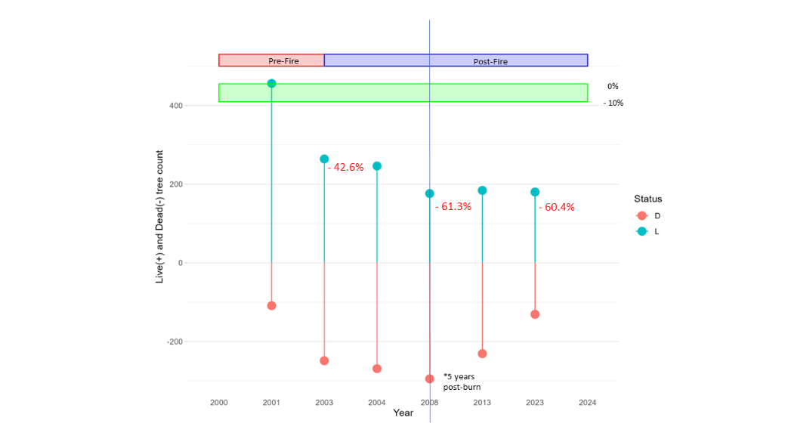

Figure 13. Overstory tree mortality from 2001 – 2023.

### Discussion

The mortality of overstory trees mirrors the findings from Objective 2's pole tree density analysis.Since the fire was a wildfire rather than a prescribed burn, it resulted in significantly higher than desired overstory tree mortality.There was delayed mortality after the fire, which continued up until 5 years post-fire, at which point tree counts leveled out. . Very few pole size trees grew into the overstory (>15.1 DBH) within this time period. Managers should consider these impacts and develop objectives and plans that help recover the desired forest condition. Our discussion and recommendations concerning forest loss are continued in sections 7.2 and 7.4.

## Objective 4. Increase herbaceous cover by 5-10% and increase diversity five years post burn

### Discussion

The herbaceous cover objective could not be validated, as the protocol was discontinued after 2004. The history of the herbaceous cover protocol can be seen in Figure 1.

# Additional Analyses

## Summary

The following analyses were performed but were not tied to a specific objective. These are commonly performed in ecology and were intended to provide information to managers about the current condition and trajectory of the Doug Fir community. We recommend that objectives be developed to assess progress towards desired future condition for this monitoring type.

## Post Burn Severity

### Results

We looked at post burn severity data to see if the fuel loading in each plot was correlated with fire severity. Burn severity varied greatly by plot (Fig. 14 and 15). While the tree density before the fire was similar between plots (in each size class), only four plots experienced stand replacement (PSME-03, PSME-07, PSME-08, PSME-09). The remaining plots were less impacted. Looking at the fuel loading data collected pre-fire, combined with post-fire burn severities, some of the highest burn severity occurred in plots with relatively low pre-fire fuel loads (Fig. 15). Conversely, some of the plots with the highest total fuel loading (PSME-01, PSME-10, PSME-05) resulted in the lowest burn severities.

### Discussion

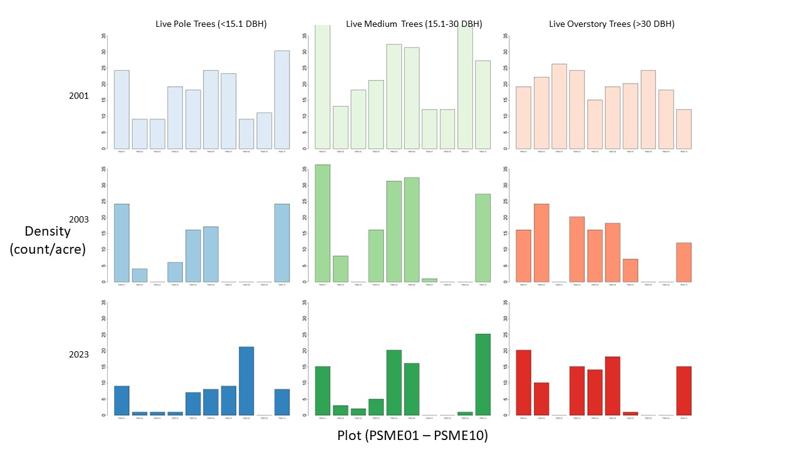

Figure 14. Live tree density pre-fire, immediately post-fire, and 20 years later, separated by size class and plot.

There are many implications from stand-replacing fires in mixed conifer forests as was seen on Mica Mountain in 2003. As mixed conifer forests are fire-adapted, they have evolved to recover from high intensity fires, but the resilience of the community is dependent on the size and shape of the stand-replacing patches (Stevens et. al 2017). Large-scale patches put the forest community at risk of tree regeneration failure and persistent type-conversion (Millar et al. 2015). More research is needed to investigate if the size and scale of the high severity patches burned on Mica Mountain have put the area at risk of a state transition, from mixed conifer forest to another community type. After 20 years, there were pole and medium sized tree growing in the high severity areas, but few overstory trees. The species composition of these new trees also should continue to be monitored to monitor and predict long-term shifts (see sections 7.3 Seedlings and 7.4 Species Composition). We recommend that future analyses be performed using the tool developed by Stevens et al. to calculate stand-replacing decay coefficients for the affected area on Mica Mountain’s. This analysis could provide more information on site (patch)-specific vulnerability to vegetation shifts and regeneration potential.

### 

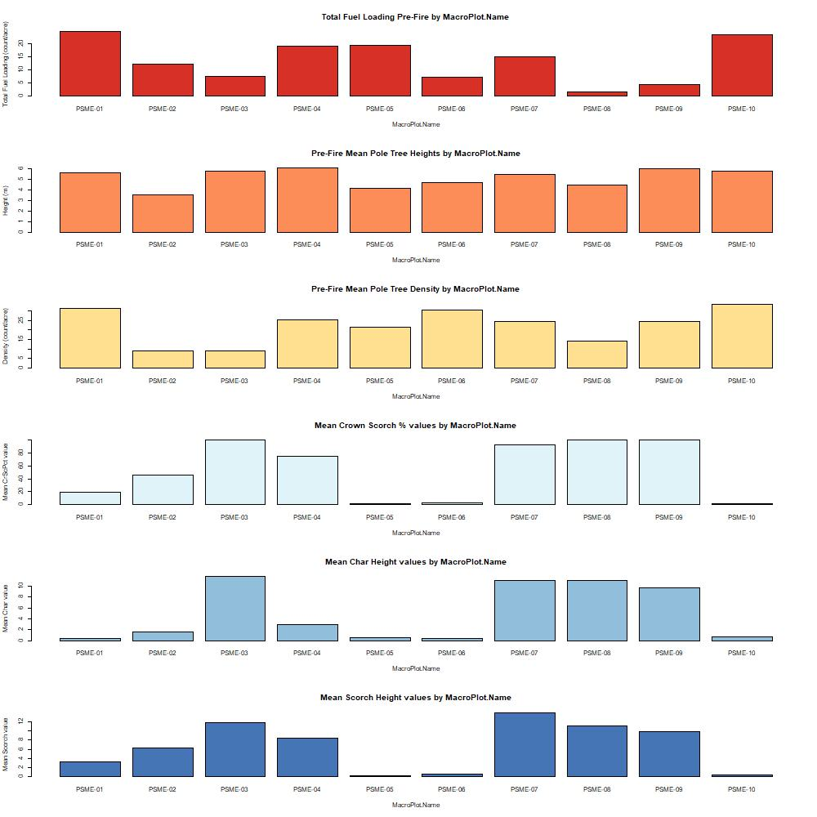

Figure 15. Total Pre-Fire Fuel Loading, Mean Pole Tree Height, and Mean Pole Tree Density per plot compared to Post-Burn Severity Metrics

The results are contrary to what we typically expect: that more fuel loading results in higher burn severity. There could be several confounding factors affecting these results, such as vegetation, topography, weather, direction of fire spread, etc. Recent studies have suggested that in mixed conifer forests, litter, duff, and 1000h fuels are primary contributors of fire energy (Birch et al. 2023). With all these factors at play, this 2023 study found that fire behavior, specifically the direction of fire relative to wind and slope (heading vs. backing) had an outsized influence on fire severity. Given the location of the monitoring plots relative to the origin of Helen’s 2 the fire (upslope from the origin), many of the plots likely burned in a head fire (Fig. 17). Fast-moving, intense head-fire, with pre-heating of upslope fuels 20th likely caused the high burn severities in PSME-03, PSME-07, PSME-08, and PSME-09, on June 20th (Figs. 16 and 17)

Despite having higher fuel loads, plots PSME-04, PSME-05, and PSME-10 had low post-burn severity. This could, again, be attributable to slope because they are located near the top of Mica Mountain, where slopes begin to flatten out. We cannot rule out other factors, like time of day, wind, rock outcrops, etc. that may have influenced the outcomes at these plots. Landscape context might have also played a role in the low post-burn severities observed in plots PSME-01 and PSME-02, which are both located in a sheltered canyon. This canyon may have slowed fire spread and lowered fire intensity in its vicinity, potentially affecting plots PSME-05, PSME-06, and PSME-10 as well.

Figure 16. Map of Douglas Fir (PSME) plots on Mica Mountain. The plots circled in red had the highest burn severity with stand replacing fires and the plots circled in green had lower severity burns

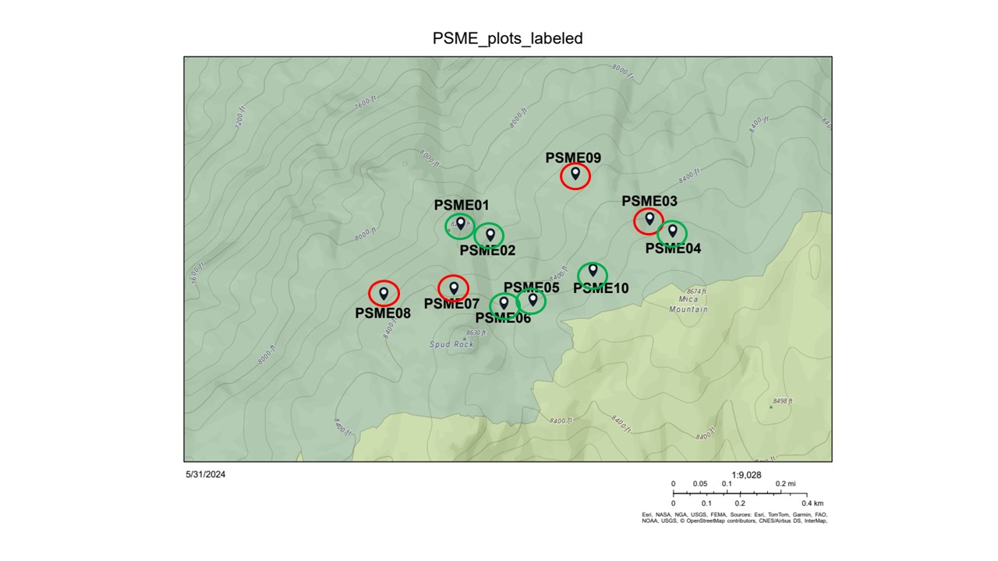

We also investigated if pole tree height or density correlated with post-burn severity (Fig. 15), under the assumption that ladder fuels may have been a contributing factor. We found that plots that had higher severity had higher average pole tree heights but lower pole tree densities.

While monitoring fuel loads is important and should continue, the Helen’s 2 fire serves as an important example where topography, landscape context, fire progression, and fire behavior can supersede this factor in explaining resulting fire severity. Current fuel loads in mixed conifer forests are just one factor that should be considered but may not turn out to be the greatest determining factor in post-burn- severity outcomes in a given community, which appears was the case in the Helen’s 2 fire.

.

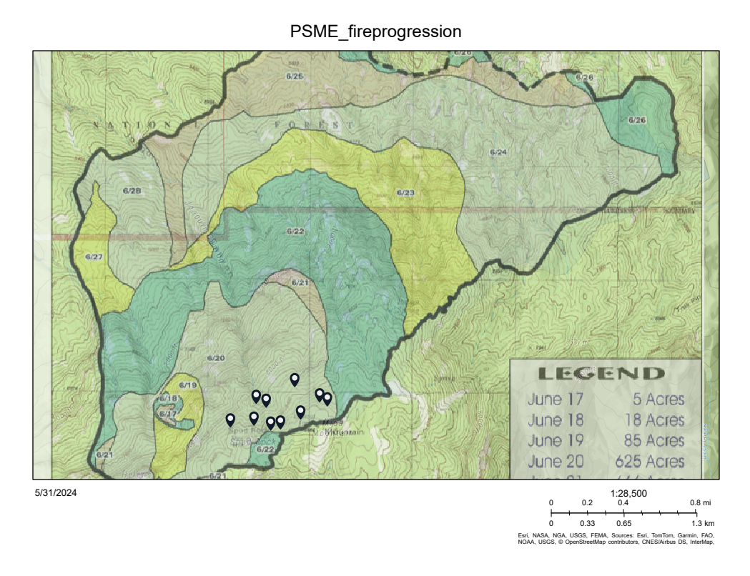

Figure 17. Map of fire progression with PSME plot locations. Refer to Figure 15. for labels of each individual plot. All plots were burned on June 20th, 2003, during the fire that burned from June 17th to June 28th.

## Seedlings

### Results

To evaluate how the mixed conifer community changed after the fire we looked at tree seedling density and species composition. Figure 18 shows seedling species composition and size class pre-fire (2001), immediately post-fire (2004), and twenty years after the fire (2023). Before the fire, the species composition was mostly distributed between Douglas Fir, White Fir, and Southwestern White Pine, with very little Gambel Oak and Ponderosa Pine. Immediately after the fire, there was a spike in new Douglas Fir seedlings, particularly in the size class 0.6. By 2023, Gambel Oak seedlings dominated all the size classes.

### Discussion

Many factors can affect post-fire recruitment and eventual shifts in vegetation. One factor that plays a large role, based on recent literature, is climate. Drought can affect the reestablishment of species and alter which species succeed in recruitment. Figure 19 shows the drought history of Mica Mountain from 2000 – 2023, showing a severe drought between 2001 and 2003, and another drought between 2008 and 2013 (climateanalyzer.org). A 2016 study by Harvey et al. observed overall post-fire seedling establishment declining with greater post-fire drought severity, but the effect varied among species. This study found no correlation between drought severity post-fire and Douglas Fir seedling establishment. Species whose establishment were negatively affected by drought included subalpine conifers, such as White Spruce and Rocky Mountain Fir. Gambel Oak was not included in the study (Harvey et al. 2016). Douglas Fir is a more shade tolerant species, which could explain why so many seedlings were established initially after the fire if the dead overstory trees had yet to fall. Gambel Oak is a slightly less shade tolerant species and is more drought tolerant than Douglas Fir (Kaufmann et. al 2016). Given the drought that followed the fire and the lack of shade caused by overstory mortality, it is understandable that Gambel oak seedlings would have the highest success in establishment. More should be collected in the future to determine the trajectory of the vegetation community, and this analysis should be taken in conjunction with the species composition data in section 7.4.

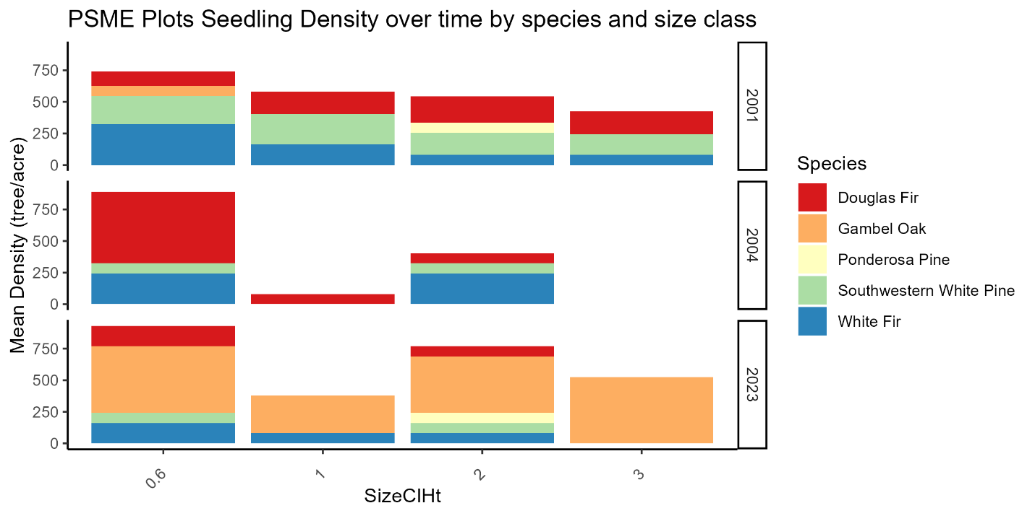

Figure 18. Douglas Fir plots seedling density over time, by species and size class.

Figure 19. Climate Analyzer Normalized Reconnaissance Drought Index Data from high elevation RMD RAWS station 2000 - 2023. “NA” = insufficient data to generate reliable estimates. Data Source: GRIDMET via climateanalyzer.org

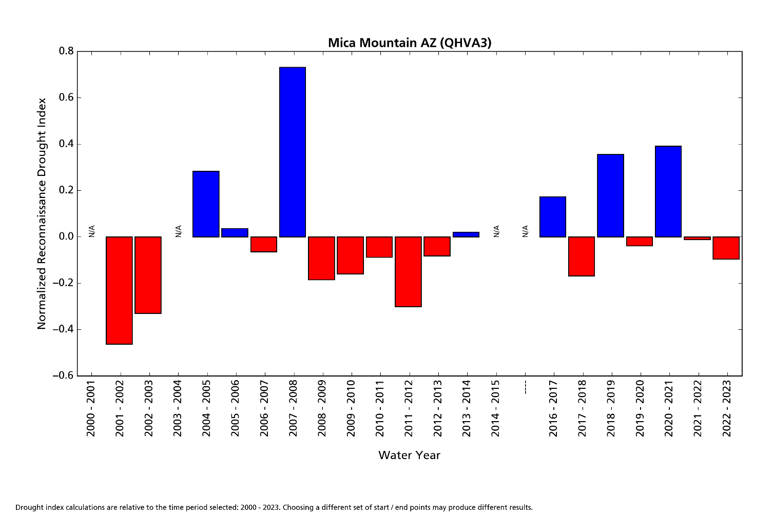

## Species Composition and Basal area

### Results

The 1992 species data is drastically different from other years (Fig. 20), yet the density data is similar to 1997 (Fig 21.). This brings into question the quality of the 1992 species data. Tree density has decreased each year in all size classes since the fire except for pole trees between the 10 and 20 year read. The relative proportion of Douglas Fir and Gambel Oak overstory trees increased while the Ponderosa Pine, Southwestern White Pine, and White Fir tree proportions decreased. Before the fire, almost half of the medium sized trees were Douglas Fir (42.4%). Immediately post-fire, the live Douglas Fir proportion dropped to 30.5% (medium trees) but by 2023 increased to 48.3%. The Gambel Oak proportion also increased in medium trees from 13.6% pre-fire to 21.8% in 2023. The most dramatic change came in the pole trees where pre-fire Gambel Oak poles only had 5.1% of the pole tree density. By 2023 the proportion had increased to almost half (47.7%), with most of the jump occurring between the 10 and 20 year reads. The pole tree size class was also the only category where the Douglas Fir tree proportion decreased from 40.9% to 23.1% between the 10 and 20 year reads.

Figure 20. Species composition of live pole, medium, and overstory trees from 1992 – 2023 as well as the density in stems/acre. Percentages represent the proportion of species composition by density.

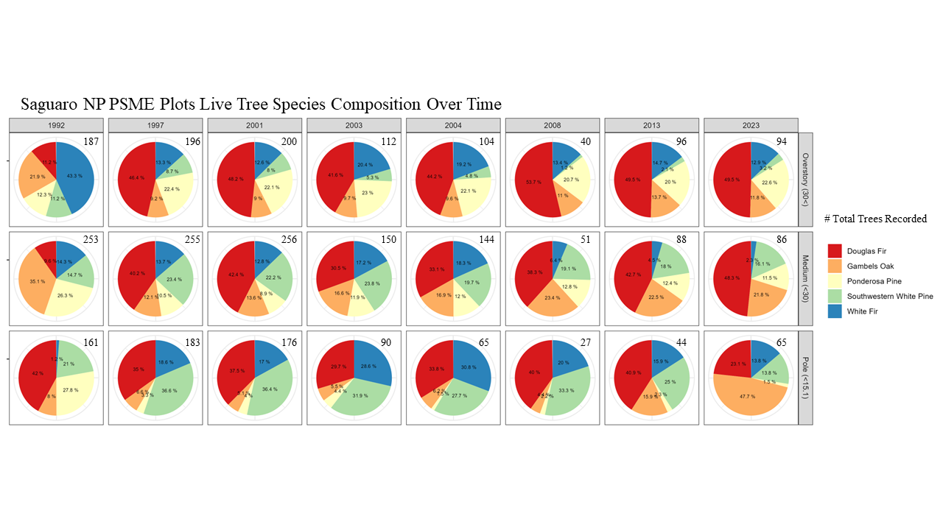

When considering species composition, it’s also helpful to look at total live basal area per acre broken down by species as shown in Figure 21 and 22. Figure 21 shows the basal area per species of plots that did not have stand replacing fires (6) and Figure 22 shows the plots that did have stand replacing fires (4). The proportion of species composition in Figure 21 does not change much after the fire. In Figure 22 we can see that the total basal area dropped dramatically after the fire and table 2 shows the data with Douglas Fir data highlighted. PSME-07 was the only plot out of the four stand replacing fire plots that had some trees survive, including Douglas Fir trees. By 2023 however, no living Douglas Fir trees remained. Plots PSME-03, PSME-08, and PSME-09 had no trees survive the fire, but some regrowth in later years (very little in PSME-09).

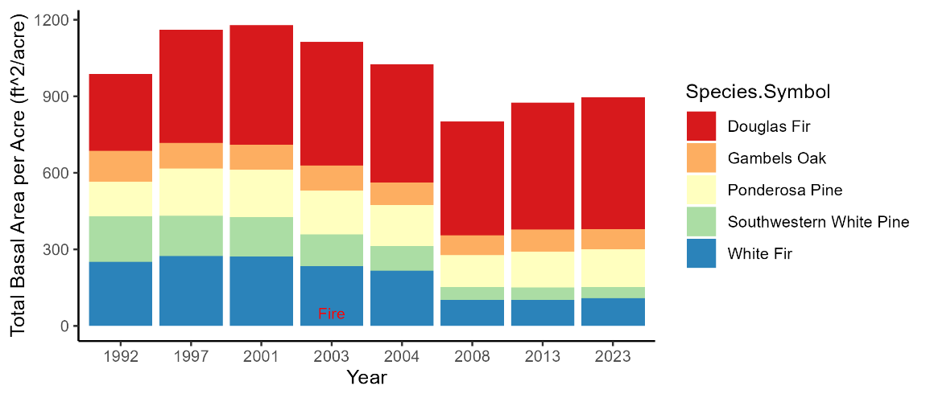

Figure 21. Live Tree Basal Area for PSME plots that burned in non-stand replacing fires (PSME-01, PSME-02, PSME-04, PSME-05, PSME-06, PSME-10)

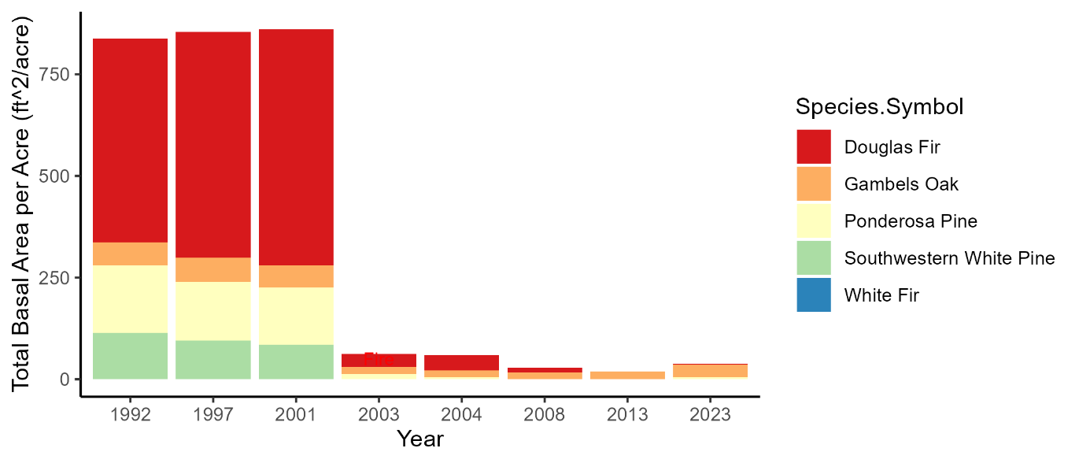

Table 2. Live Tree Basal Area for PSME plots that burned in stand replacing fires (PSME-03, PSME-07, PSME-08, PSME-09) with data for each species. Douglas fir rows are highlighted.

Figure 22. Live Tree Basal Area for PSME plots that burned in stand replacing fires (PSME-03, PSME-07, PSME-08, PSME-09)

|  |  |  |  |
| --- | --- | --- | --- |
| Year | MacroPlot.Name | Species.Symbol | totalba_peracre |
| 2003 | PSME-07 | Douglas Fir | 32.25719 |
| 2003 | PSME-07 | Gambel Oak | 16.75178 |
| 2003 | PSME-07 | Ponderosa Pine | 13.29723 |
| 2004 | PSME-07 | Douglas Fir | 36.22296 |
| 2004 | PSME-07 | Gambel Oak | 16.75178 |
| 2004 | PSME-07 | Ponderosa Pine | 5.261957 |
| 2004 | PSME-08 | Douglas Fir | 1.183563 |
| 2008 | PSME-07 | Douglas Fir | 11.38983 |
| 2008 | PSME-07 | Gambel Oak | 16.75178 |
| 2013 | PSME-07 | Gambel Oak | 17.20829 |
| 2013 | PSME-08 | Gambel Oak | 1.393892 |
| 2023 | PSME-03 | Douglas Fir | 2.568423 |
| 2023 | PSME-03 | Ponderosa Pine | 2.615121 |
| 2023 | PSME-07 | Gambel Oak | 14.92451 |
| 2023 | PSME-07 | White Fir | 0.492638 |
| 2023 | PSME-08 | Gambel Oak | 15.35348 |
| 2023 | PSME-09 | Ponderosa Pine | 1.762858 |

### Discussion

There is a noticeable difference in the species composition shifts between plots that burned at a high severity and a low severity. Though the plots represent a small portion of the area burned in the fire, some inferences can be made about the rest of the park’s Douglas Fir forest that burned. As seen in Figure 23. the Helen’s 2 fire burned only a section of the Rincon Mountain District, and in Figure 24 we see the PSME plot locations were only in a smaller, higher severity section of the fire. (See also Figure 17 for plot location data within the fire perimeter. Though 4/10 of the monitoring plots had stand-replacing fires burn, the monitoring plots were placed within the area of the fire that had the highest severity burn. The rest of the area that burned may have recovered more like the remaining six plots. The 2020 study by Davis et al. asked where Ponderosa Pine and Douglas Fir forests were most vulnerable to stand-replacing fire, post-fire regeneration failure, and fire-catalyzed vegetation shifts in the US intermountain west. The Apache Highlands, which includes Saguaro National Park, was the most vulnerable, with over half of the range falling within the most severe post fire recruitment index (0-0.2 out of the next 5 years being climatically suitable for recruitment (Davis et al. 2020). There is a risk of forest loss and vegetation shift in the areas severely burned by the Helen’s 2 fire. However, the plots that experienced lower severity burns show promising signs of recovery and stable species composition. The fire severity maps of the Helen’s 2 wildfire suggest that the majority of the burned area is more likely to resemble the six plots with lower severity burns rather than the four plots that experienced high severity burns. Nevertheless, it is important for management to continue to monitor and manage areas that burned severely to encourage forest regrowth and promote species of interest, including Douglas Fir.

Figure 24. PSME plot locations with fire severity.

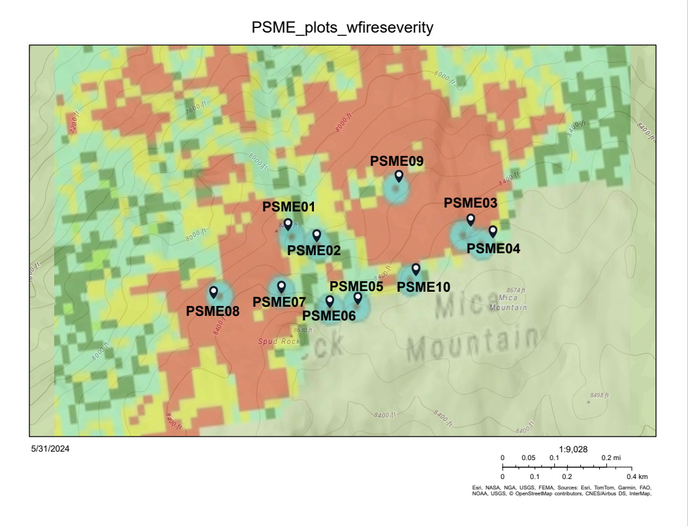

Figure 23. Perimeter of Helen’s 2 fire (2003) and fire severity with Saguaro National Park Rincon Mountain District boundary.

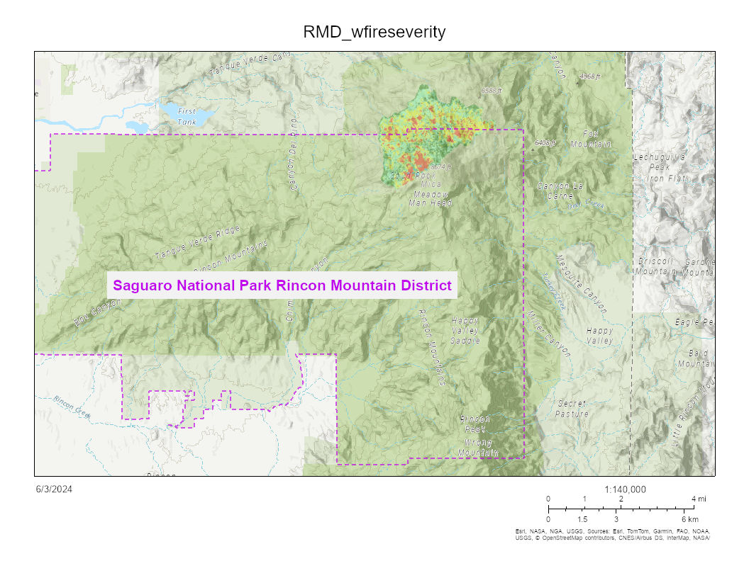

# Conclusion

During the QAQC process we performed quality control on the historical Douglas Fir monitoring type data from Mica Mountain. Throughout the process, adjustments to the data were made and documented, as well as the efficacy of certain protocols. In our analysis of the data, we found that forest recovery has varied greatly within the different Douglas Fir plots. A high severity fire put some areas at risk of forest loss, recruitment failure, and fire-catalyzed vegetation shifts, while areas that burned at low severity recovered well from the fire, maintaining a majority of Douglas Fir overstory trees. Current fuel loading levels on Mica Mountain present a serious risk of a catastrophic wildfire burning the area at a high severity. Recent literature has shown increased vulnerability in southeastern Arizona to the impacts of climate change, which could lead to forest loss and the loss of valuable ecosystem benefits provided by mixed conifer forests. Management must take timely action in order to protect and preserve this ecosystem for future generations.

# Management Recommendations

1. Perform a low-intensity, backing fire, prescribed burn on the North Slope of Mica Mountain in 2024, using the 20-year reads from 2023 as a pre-burn assessment. Consider a dormant season or winter burn to reduce fuels and/or piling and burning in the winter months.
   1. Supporting evidence:
      1. Present fuel loading levels presents a risk of catastrophic wildfire.
      2. A high intensity wildfire presents an increased risk of post-fire regeneration failure, vegetation shifts, and forest loss.
      3. A prescribed, low intensity burn can eliminate hazardous fuel build up while encouraging forest preservation.
2. Develop new objectives for the Douglas Fir monitoring type for the future and discontinue canopy cover protocol.
   1. Supporting evidence:
      1. The last objectives for this area were developed when the plots were established (~1990) and they are outdated.
      2. Climate change and invasive grasses present new challenges to the area that require re-evaluation of priorities for management.
      3. See section 5.3 for canopy cover protocol specifics.
3. Continue to perform quality control on data from other monitoring types in Saguaro National Park and research the impact of wildfires in those areas in a timely manner.
   1. Supporting evidence:
      1. Data from other monitoring types will have similar if not more QAQC challenges to address before we can rely on it to inform management.
      2. Code to perform quality control and analysis is already written for Saguaro’s protocol and can be used to get quicker information about other monitoring types.
      3. The urgency of climate change will impact fire management needs and responses.

# Literature Cited

Birch, J. D., Dickinson, M. B., Reiner, A., Knapp, E. E., Dailey, S. N., Ewell, C., Lutz, J. A., & Miesel, J. R. (2023). Heading and backing fire behaviors mediate the influence of fuels on wildfire energy. *International Journal of Wildland Fire, 32*, 1244-1261.

Betsy A. Goodrich, Kristen M. Waring, *Pinus strobiformis* seedling growth in southwestern US mixed conifer forests in managed and non-managed stands, Forestry: An *International Journal of Forest Research*, Volume 90, Issue 3, May 2017, Pages 393–403, <https://doi.org/10.1093/forestry/cpw057>

Constance I. Millar, Nathan L. Stephenson ,Temperate forest health in an era of emerging megadisturbance. *Science* 349,823-826 (2015). DOI:10.1126/science.aaa9933

Cram, D., Saud, P., Baker, T., (2017) Structure and Composition of a Dry Mixed-Conifer Forest in Absence of Contemporary Treatments, Southwest, USA. *Forests* 2017, 8(9), 349; <https://doi.org/10.3390/f8090349>

Davis, K. T., Higuera, P. E., Dobrowski, S. Z., Parks, S. A., Abatzoglou, J. T., Rother, M. T., & Veblen, T. T. (2020). Fire-catalyzed vegetation shifts in ponderosa pine and Douglas-fir forests of the western United States. *Environmental Research Letters, 15*(10).

Harvey, B. J., Donato, D. C., & Turner, M. G. (2016). High and dry: post-fire tree seedling establishment in subalpine forests decreases with post-fire drought and large stand-replacing burn patches. *Global Ecology and Biogeography, 25*(6), 655-669.

Hurteau, M. D., Bradford, J. B., Fulé, P. Z., Taylor, A. H., & Martin, K. L. (2013). Climate change, fire management, and ecological services in the southwestern US. *Forest Ecology and Management, 327*, 280-289.

Jens T. Stevens, Brandon M. Collins, Jay D. Miller, Malcolm P. North, Scott L. Stephens, Changing spatial patterns of stand-replacing fire in California conifer forests, *Forest Ecology and Management*, Volume 406, 2017, Pages 28-36, ISSN 0378-1127, https://doi.org/10.1016/j.foreco.2017.08.051.

Merrill R. Kaufmann, Daniel W. Huisjen, Stanley Kitchen, Mike Babler, Scott R. Abella, Todd S. Gardiner, Darren McAvoy, Josh Howie, Douglas H. Page Jr. (2016) Gambel Oak Ecology and Management in the Southern Rockies: The Status of Our Knowledge SRFSN Publication 2016-1. Fort Collins, CO: Colorado State University, *Southern Rockies Fire Sciences Network*. 16 p.

Poulos, H.M.; Freiburger, M.R.; Barton, A.M.; Taylor, A.H. Mixed-Severity Wildfire as a Driver of Vegetation Change in an Arizona Madrean Sky Island System, USA. Fire 2021, 4, 78. https://doi.org/ 10.3390/fire4040078